Unit exam with answers

Unit 2 Molecular interactions and reactions

Name:

Class:

Time permitted: 70 minutes

|  |  |  |  |  |
| --- | --- | --- | --- | --- |
|  | Section | Number of questions | Marks available | Marks achieved |
| A | Multiple choice | 30 | 30 |  |
| B | Short answer | 10 | 40 |  |
|  | Total |  | 70 |  |

Grade:

Comments:

Section A Multiple choice (30 marks)

Section A consists of 30 questions, each worth one mark. Each question has only one correct answer. Circle the correct answer. Attempt all questions. Marks will not be deducted for incorrect answers. You are advised to spend no more than 30 minutes on this section.

1 Forces between molecules are known as:

A intermolecular.

B intramolecular.

C covalent.

D ionic.

2 Which of the following is not an example of a linear molecule?

A CO2

B BeCl2

C I2

D NH3

3 An electron dot formula usually represents:

A lone pairs of valence electrons only.

B all valence electrons, shared and unshared.

C bonding pairs of electrons only.

D the structural formula of the compound.

4 Which of the following is false?

A Lone electron pairs are closer to a single nucleus so occupy more space.

B Bonding pairs are shared by two atoms hence occupy less space.

C Bonding pairs cause more repulsion than lone pairs.

D Bonding pairs cause less repulsion than lone pairs.

5 Which of the following is the weakest type of molecular force or bond?

A Hydrogen bond

B Dipole–dipole force

C Dispersion force

D Covalent bond

6 Some insects are able to walk on water because of:

A the high specific heat capacity of water.

B the density of water.

C capillary action.

D high surface tension.

For questions 7–9 refer to the graph below.

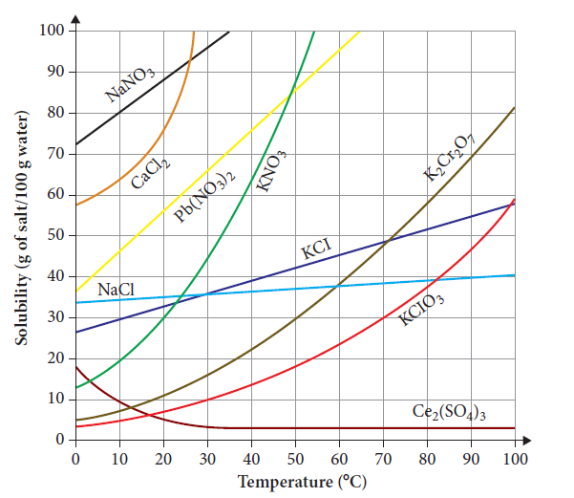

7 Which salts have the same solubility at 60°C?

A NaCl and K2CrO7

B NaCl, KCl, KClO3, K2CrO7 and Ce2(SO4)3

C KCl and K2CrO7

D CaCl2 and Pb(NO3)2

8 Which of the following salts has a solubility that increases at an increasing rate as temperature increases?

A NaNO3

B KCl

C KNO3

D Pb(NO3)2

9 The solubility of K2Cr2O7 at 90°C is closest to:

A 5 g of salt/100 g water.

B 70%(w/w).

C 30 g of salt/100 g water.

D it is too far off the graph to read.

10 Which of the following is not an example of an emulsion?

A Mayonnaise

B Oil and vinegar added together to make a salad dressing

C Milk

D Butter

11 Which of the following is false?

A All chlorides are soluble.

B All nitrates are soluble.

C All group 1 salts are soluble.

D All ammonium salts are soluble.

12 Molarity is a measure of:

A mass.

B moles.

C concentration.

D volume.

13 The number of moles in 150 mL of 0.95 mol L–1 sodium bromide solution is:

A 0.158 mol

B 6.33 mol

C 142.5 mol

D 0.143 mol

14 Which of the following does not describe ‘hard’ water?

A Can have a higher concentration of calcium ions than soft water

B Has a higher concentration of magnesium ions than soft water

C Lathers quite easily

D Difficult to form a lather

15 Which of the following is not normally used in an accurate dilution procedure carried out in the laboratory?

A Measuring cylinder

B Pipette

C Volumetric flask

D Funnel

16 Acids:

A conduct electricity in solution.

B turn red litmus blue.

C have a pH > 7.

D have a bitter taste.

17 The concentration of OH– ions at pH 9 is equal to:

A 10–9 mol L–1.

B 10–5 mol L–1.

C 5 mol L–1.

D 9 mol L–1.

18 Which of the following cannot tell you the degree of acidity of a solution?

A Methyl orange indicator with a range chart

B pH meter

C pH probe

D Litmus paper

19 Which of the following is the correct test for the chloride anion?

A Addition of ammonia produces a thick white precipitate

B Addition of silver nitrate produces a white precipitate

C Addition of dilute nitric acid produces bubbles of gas

D Litmus paper – the pH of the solution is <7

20 Which of the following is not a unit of gas pressure?

A mmHg

B Pa

C N

D atm

21 Which of the following scientists is not known for his contribution to understanding the properties of gases?

A Lord Kelvin

B Robert Boyle

C Jacques Charles

D Amedeo Avogadro

22 Which of the following is true?

A The molar volume of a gas at STP = 24.5 L.

B Gas volume is directly proportional to gas pressure.

C Temperature and gas volume are inversely proportional.

D Gas pressure and temperature are directly proportional.

23 Which of the following is not an example of a rate?

A Speed

B Distance

C Acceleration

D Volume of gas produced per minute

24 A reaction is allowed to go until completion. Which of the following would increase the quantity of products in the reaction?

A Carrying out the reaction in a larger container

B Increasing the reaction rate by increasing the temperature

C Adding more reactants into the reaction vessel

D Increasing the surface area of the reactants

25 Which of the following is a measure of the kinetic energy of particles in a reaction?

A Pressure

B Surface area

C Concentration

D Temperature

26 In an endothermic reaction:

A energy is absorbed from the surroundings.

B energy is released to the surroundings.

C ΔH is negative.

D the rate is slower than in an exothermic reaction.

For questions 27 and 28 refer to the graph below.

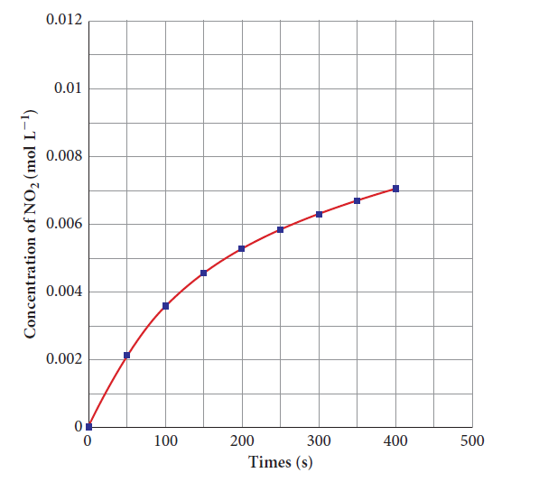

27 What was the concentration of NO2 gas closest to at 150 seconds?

A 0.002 mol L–1

B 0.004 mol L–1

C 0.005 mol L–1

D 0.0045 mol L–1

28 Which part of the reaction had the fastest rate?

A 0–400 s

B 350–400 s

C 0–50 s

D 50–100 s

For questions 29 and 30 refer to the table below.

|  |  |
| --- | --- |
| Time  (s) | Volume of gas produced  (mL) |
| 0 | 0 |
| 20 | 10 |
| 40 | 25 |
| 60 | 43 |
| 80 | 50 |
| 100 | 50 |

29 The average rate of reaction is:

A 1.0 mL s–1.

B 0.5 mL s–1.

C 50 mL s–1.

D 0.625 mL s–1.

30 At what time did the reaction reach completion?

A 20 s

B 60 s

C 80 s

D 100 s

Section B Short answer (40 marks)

Section B consists of 10 questions. Write your answers in the spaces provided. You are advised to spend 40 minutes on this section.

1 Describe two properties of water that depend on the strength of the intermolecular forces of attraction in water. (2 marks)

Answer: Water has a relatively high boiling point. This is because of the strong intermolecular hydrogen bonds that ‘hold’ the molecules close together. A relatively large amount of energy is required to separate the molecules from one another and change it into a gas. (1 mark)

Water has a high surface tension. Hydrogen bonding occurs in all directions and is strong enough to hold the molecules together. At the surface, there is an imbalance. The liquid molecules are attracted to each other and exert a net force that pulls them together. (1 mark)

2 A student conducted an experiment on the effect of charged objects on three different liquids. Below is the method.

A burette was filled with 50 mL of water (H2O) and the tap released, allowing a fine stream of water to fall into a beaker below.

An ebonite rod was rubbed with fur, making it negatively charged.

The ebonite rod was brought near to the stream of water and the effects were observed.

This was repeated with a glass rod rubbed with wool to make it positively charged.

The entire experiment was repeated for the liquids methanol (CH3OH) and hexane (C6H14).

Below is a table of the student’s results.

|  |  |  |
| --- | --- | --- |
| Liquid stream | Movement of liquid stream in response to: | |
| Negative charges | Positive charges |
| Water (H2O) | Stream ‘bends’ toward rod (attracted to rod) | Stream ‘bends’ toward rod (attracted to rod) |
| Methanol (CH3OH) | Stream ‘bends’ toward rod (attracted to rod) | Stream ‘bends’ toward rod (attracted to rod) |
| Hexane (C6H14) | No stream movement | No stream movement |

Use your understanding of the types of intermolecular bonds to justify these results. Use a diagram to support your answer. (3 marks)

Answer: The water and methanol are attracted to both the positive and negative charges. This suggests that both water and methanol are polar. Both contain covalent O—H bonds; the hydrogen becomes slightly positive and is attracted to the negatively charged rod, while the oxygen becomes slightly negative and is attracted to the positively charged rod.

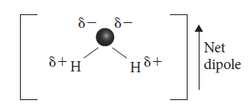

Hexane, although it has polar bonds, is a symmetrical molecule; hence there is no net dipole and the molecule is non-polar. With no slightly negative or positive end, it is not attracted to charged objects, as shown by the steady stream of hexane being undeflected by the rods.

3 Explain why carbon tetrachloride is a non-polar substance, even though it contains polar bonds. (2 marks)

Answer: The C—Cl bond is polar because Cl is more electronegative than C. This forms a dipole where the Cl has a slightly negative charge and the C a slightly positive charge. This is true for all four C—Cl bonds in CCl4. However, the CCl4 molecule is symmetrical. As one dipole cancels the other out the result is no net dipole, thus it is not a polar molecule.

4 a Write an ionic equation for the dissociation of potassium chloride in water. (1 mark)

Answer: KCl(aq) 🡪 K+(aq) + Cl–(aq)

b Use the graph below to answer the following questions.

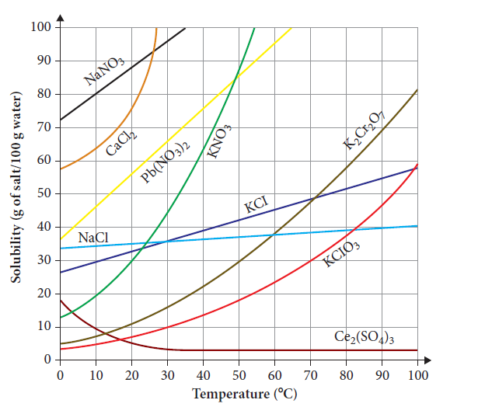

i Calculate the mass of potassium chloride that would be dissolved in 50 mL of water at 30°C. (1 mark)

Answer: At 30°C, 35 g of salt is dissolved in 100 g of water. Therefore, 17.5 g would be dissolved in 50 g of water.

ii How much hotter must a solution be to increase the solubility of potassium chloride from 40 g/100 g to 50 g/100 g? (1 mark)

Answer: 42.5°C to 75°C = 32.5°C hotter

5 Use the solubility data below to answer the following question.

|  |  |
| --- | --- |
| Soluble anions | Exceptions |
| NO3– | None |
| CH3COO– | Ag+ slightly soluble |
| Cl– | Ag+ insoluble, Pb2+ slightly soluble |
| Br– | Ag+ insoluble, Pb2+ slightly soluble |
| I– | Ag+, Pb2+ insoluble |
| SO4– | Ba2+, Pb2+, Sr2+ insoluble, Ag+, Ca2+ slightly soluble |
| Insoluble anions | Exceptions |
| OH– | Group 1, NH4+, Ba2+, Sr2+ soluble; Ca2+ slightly soluble |
| O2– | Group 1, NH4+, Ba2+, Sr2+, Ca2+ soluble |
| S2– | Groups 1 and 2, NH4+ soluble |
| CO32– | Group 1, NH4+ soluble |
| SO32– | Group 1, NH4+ soluble |

a Define the term ‘precipitation reaction’. (1 mark)

Answer: When two clear ionic solutions are added together, sometimes they react to produce a solid called a precipitate. This type of reaction is known as a precipitation reaction.

b A student has a sample of a solution but the label has fallen off. All he knows is that the solution is a nitrate of either Pb2+, Ag+, Cu2+ or Ba2+. Use the table above to describe tests you could do to determine the identity of the solution. Write net ionic equations for any positive results. (3 marks)

Answer: Cu2+ solutions are blue. If the solution is not blue, then it is silver, lead or barium.

Leave a sample of the solution in sunlight. If it turns black then it is AgNO3(aq).

Add NaOH(aq). If a precipitate forms the solution is Pb(NO3)2(aq).

Pb2+ + 2OH– 🡪 Pb(OH)2(s)

If no precipitate forms the cation is Ba2+.

c Are the above methods qualitative or quantitative? Explain your answer. (1 mark)

Answer: Qualitative. We are determining the identity of the ion, not the quantity that has been produced.

6 a Use diagrams of particles in beakers to describe the difference between a solution that is twice as concentrated as another solution. (2 marks)

Answer: If the solutions have the same number of solvent particles then a solution that is twice as concentrated will have double the number of solute particles in the solution.

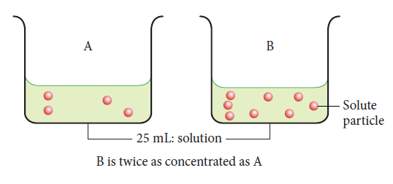

b Calculate the mass of sodium nitrate required to be added to 250 mL of deionised water to make up a 0.040 mol L–1 solution. (2 marks)

Answer:

n = cV

= 0.04 × 0.250

= 0.01 mol

m = n × M

= 0.04 × 85

= 3.4 g

7 Lemon juice has a pH of 3, milk has a pH of 6 and baking soda solution, a pH of 9.

a Classify the solutions above as either acidic or alkaline. (1 mark)

Answer: Lemon juice is acidic, milk is slightly acidic, baking soda solution is alkaline.

b Compare the relative strength of lemon juice and milk. (1 mark)

Answer: Milk is 3 pH units weaker than lemon juice. As pH is a logarithmic scale it means milk is 1000 times weaker than lemon juice.

c Determine the hydrogen ion concentration of the baking soda solution. (1 mark)

Answer: baking soda of pH =9 has a hydrogen ion concentration of 10–9 mol L-1.

d Determine the OH– concentration of the baking soda solution. (1 mark)

Answer: baking soda of pH =9 has a hydroxide ion concentration of 10–5 mol L–1.

8 A student added excess sulfuric acid solution to 1.3 g of sodium hydrogen carbonate powder and collected the gas produced.

a Write a balanced chemical equation for this reaction. (2 marks)

Answer: H2SO4(aq) + 2NaHCO3(s) 🡪 2CO2(g) + 2H2O(l) + Na2SO4(aq)

b Determine the volume of gas produced at standard laboratory conditions. (2 marks)

Answer: nNaHCO3 = nCO2 = 

 = 0.0154...

VCO2 = 0.0154… × 24.5

 = 0.379…

= 0.38 L

c Calculate the pressure required to compress the gas to a quarter of the original volume at 17°C, from standard laboratory conditions. (2 marks)

Answer:

 = 

 = 

P2 = 

P2 = 394.3 kPa

d Convert your answer to part c to atmospheres. (1 mark)

Answer: = 3.89 atm

9 A 0.15 g zinc pellet was added to 10 mL of 0.20 mol L–1 sulfuric acid. A slow, steady stream of gas bubbles was given off.

a List three different ways in which you could increase the rate of reaction. Briefly describe how each increases the rate. (4 marks)

Answer: Increase the surface area of the zinc pellet by crushing it into a powder. This increases surface area, increasing the number of particles available for collision in a given time.

Increase the concentration of the reactant (acid). Increasing the number of particles in a given volume means the number of collisions increase.

Increase the temperature of the solution. By heating the acid, the average kinetic energy and the average speed of the reactant particles increases, resulting in more frequent collisions between particles, and this will increase the rate of reaction.

b Describe at least two observations or measurements you could make to help you determine the relative rate of reaction. (2 marks)

Answer: Could measure time taken for the zinc to disappear, in minutes, using a stopwatch. (1 mark) Could also measure the volume of gas collected (mL) over time, by collecting the gas with a syringe apparatus. When bubbles stop, the reaction has ceased. (1 mark)

10 Ammonia is a very useful chemical that is produced industrially by the Haber process. Nitrogen and hydrogen gases are reacted together (in the presence of an iron catalyst) to produce ammonia gas. Certain conditions of temperature and pressure and volume of reactant gases are observed. The reaction is:  
N2(g) + 3H2(g) ⇌ 2NH3(g) ΔH = –92 kJ mol–1

a Identify whether the production of ammonia is endothermic or exothermic. (1 mark)

Answer: Exothermic, as ΔH is negative.

b Identify the volume ratio of reactant gases required in the reactor. (1 mark)

Answer: 1 volume of nitrogen gas to every 3 volumes of hydrogen gas.

c Why do you think the use of a catalyst is preferred to increase the rate of reaction rather than just using very high temperatures or pressures? (2 marks)

Answer: Increasing temperatures and/or pressure to very high levels can be dangerous, particularly with gases. It can also increase expenses as it costs extra to reinforce the reaction chamber so it can withstand higher temperatures and pressures. There must be a compromise temperature and pressure to increase the rate of reaction without incurring high costs or threatening safety. Adding a catalyst is one way to avoid these problems. It lowers the activation energy but is not itself consumed in the reaction.